Qwen 3 14b
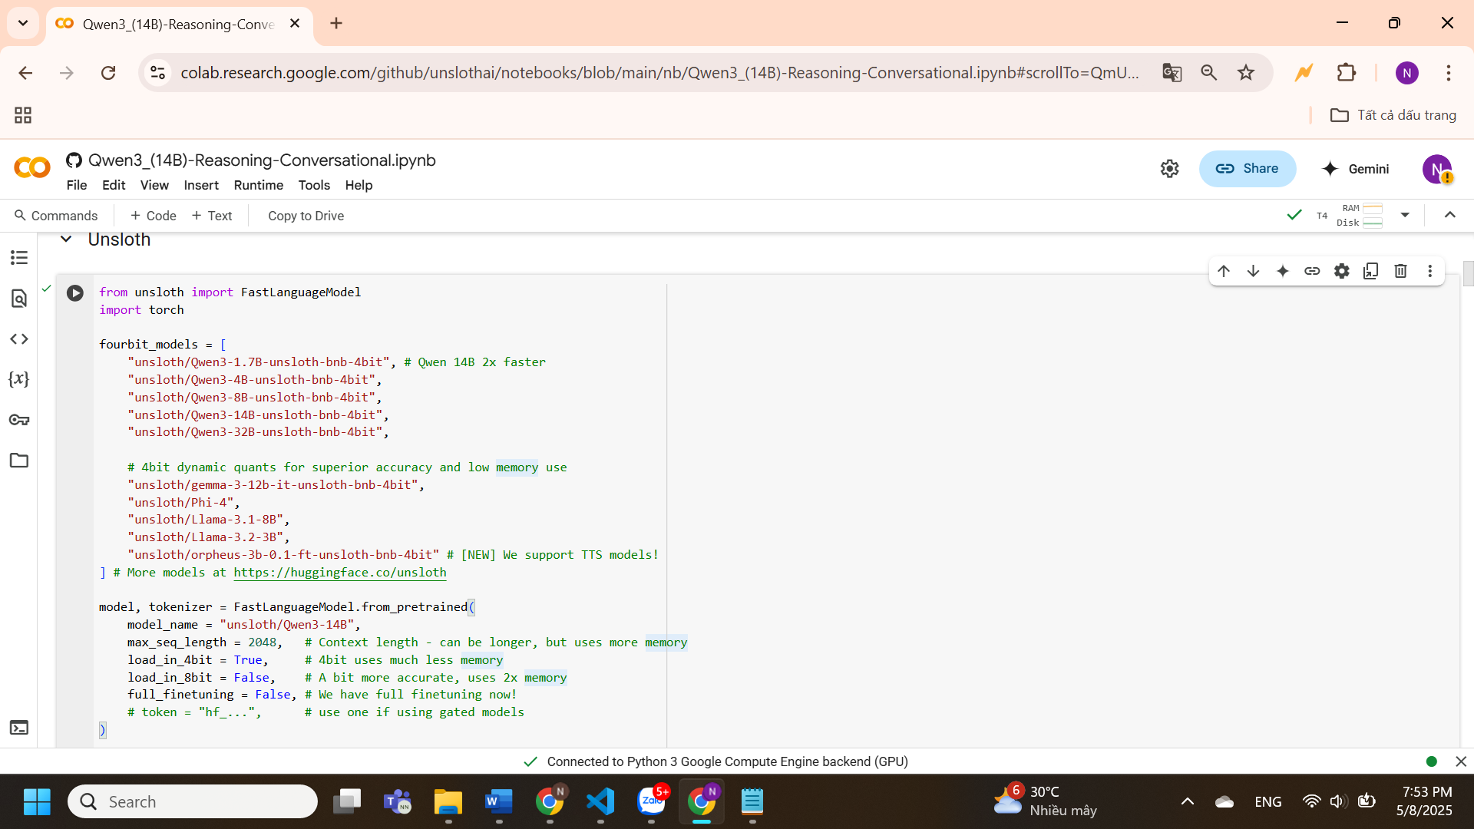
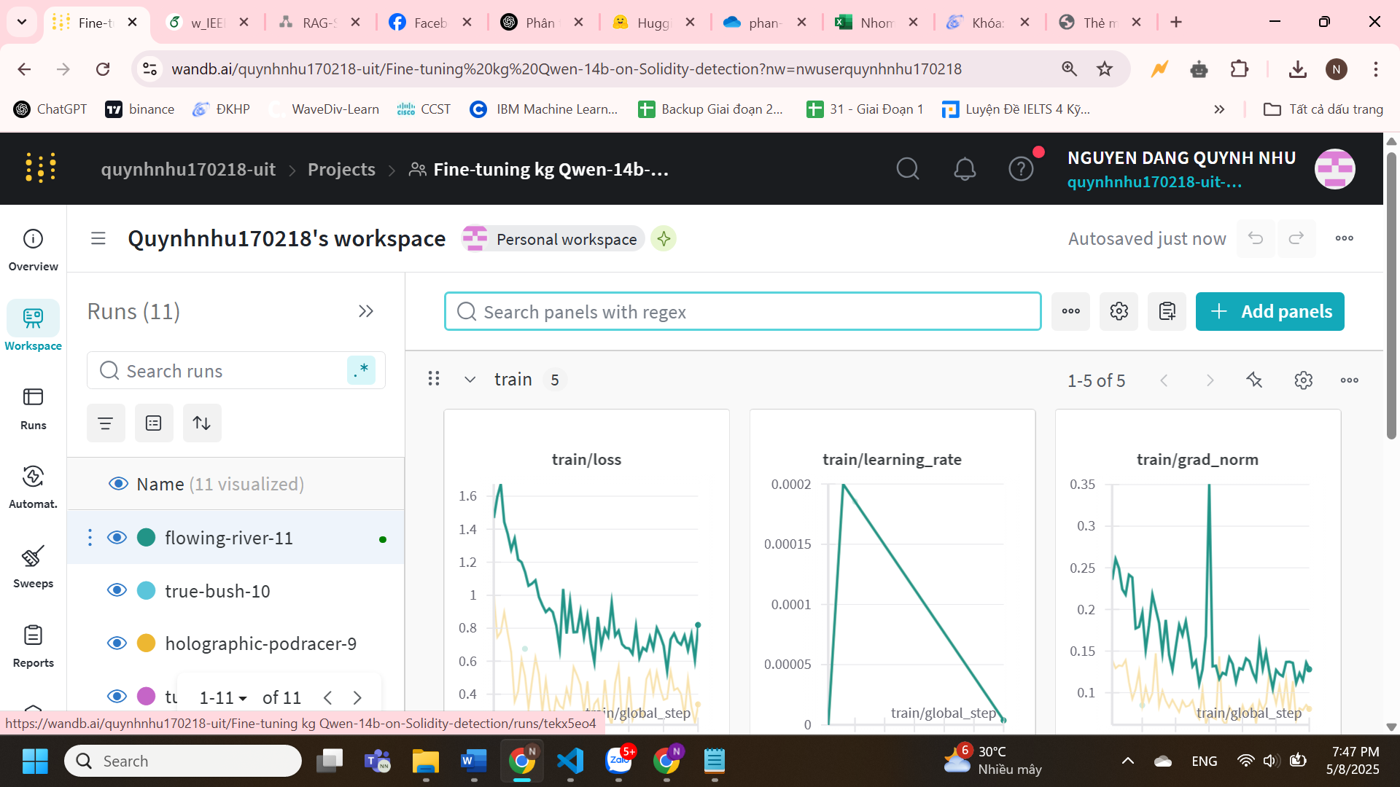

Qwen coder 2.5 14b

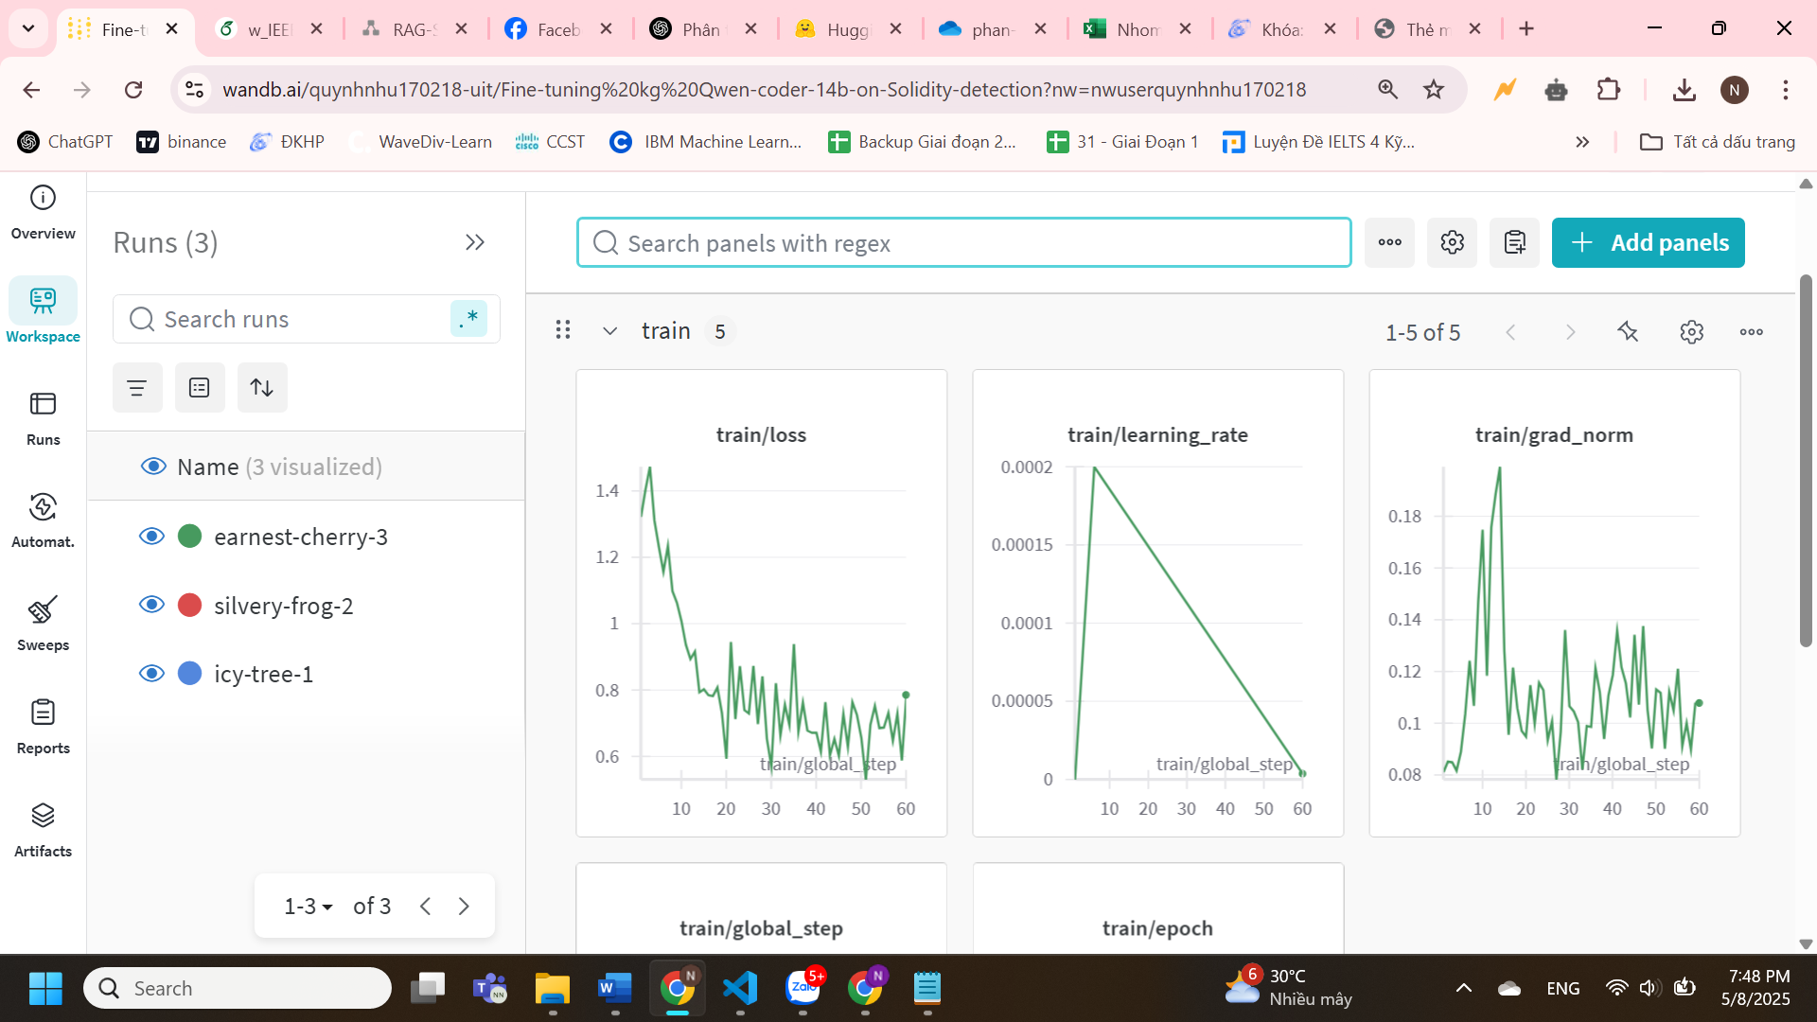

Cả hai thằng đều query ra như nhau after 60 step
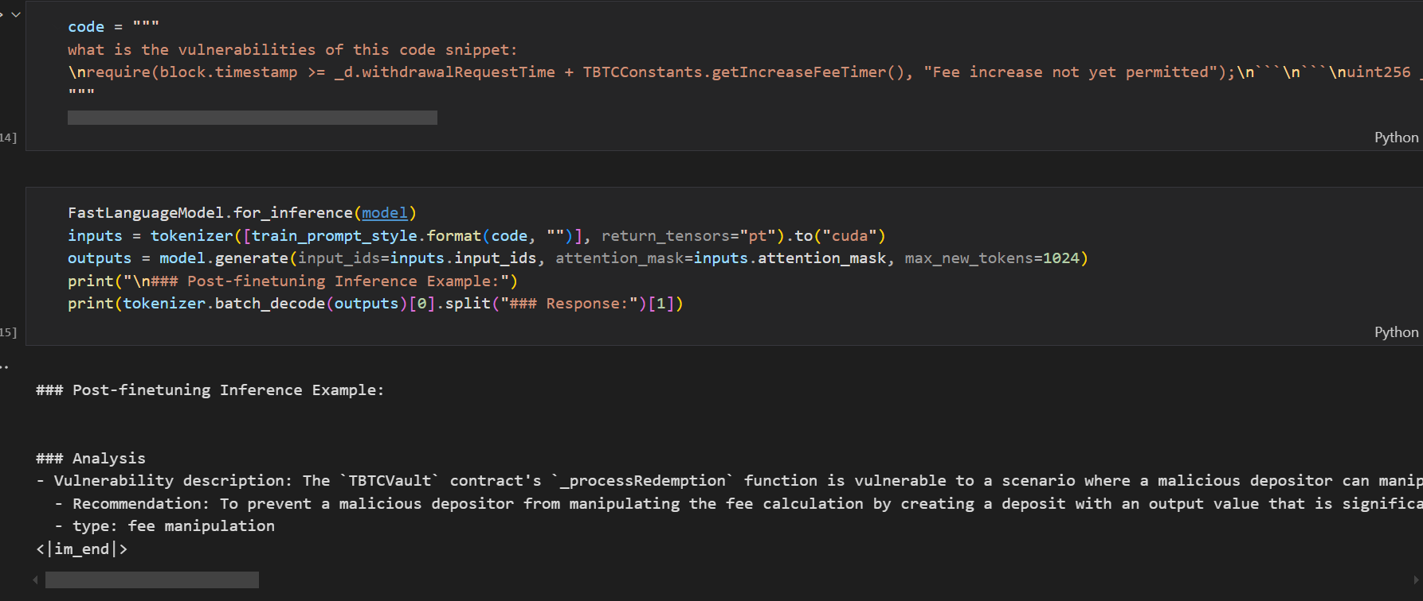

Non vul:
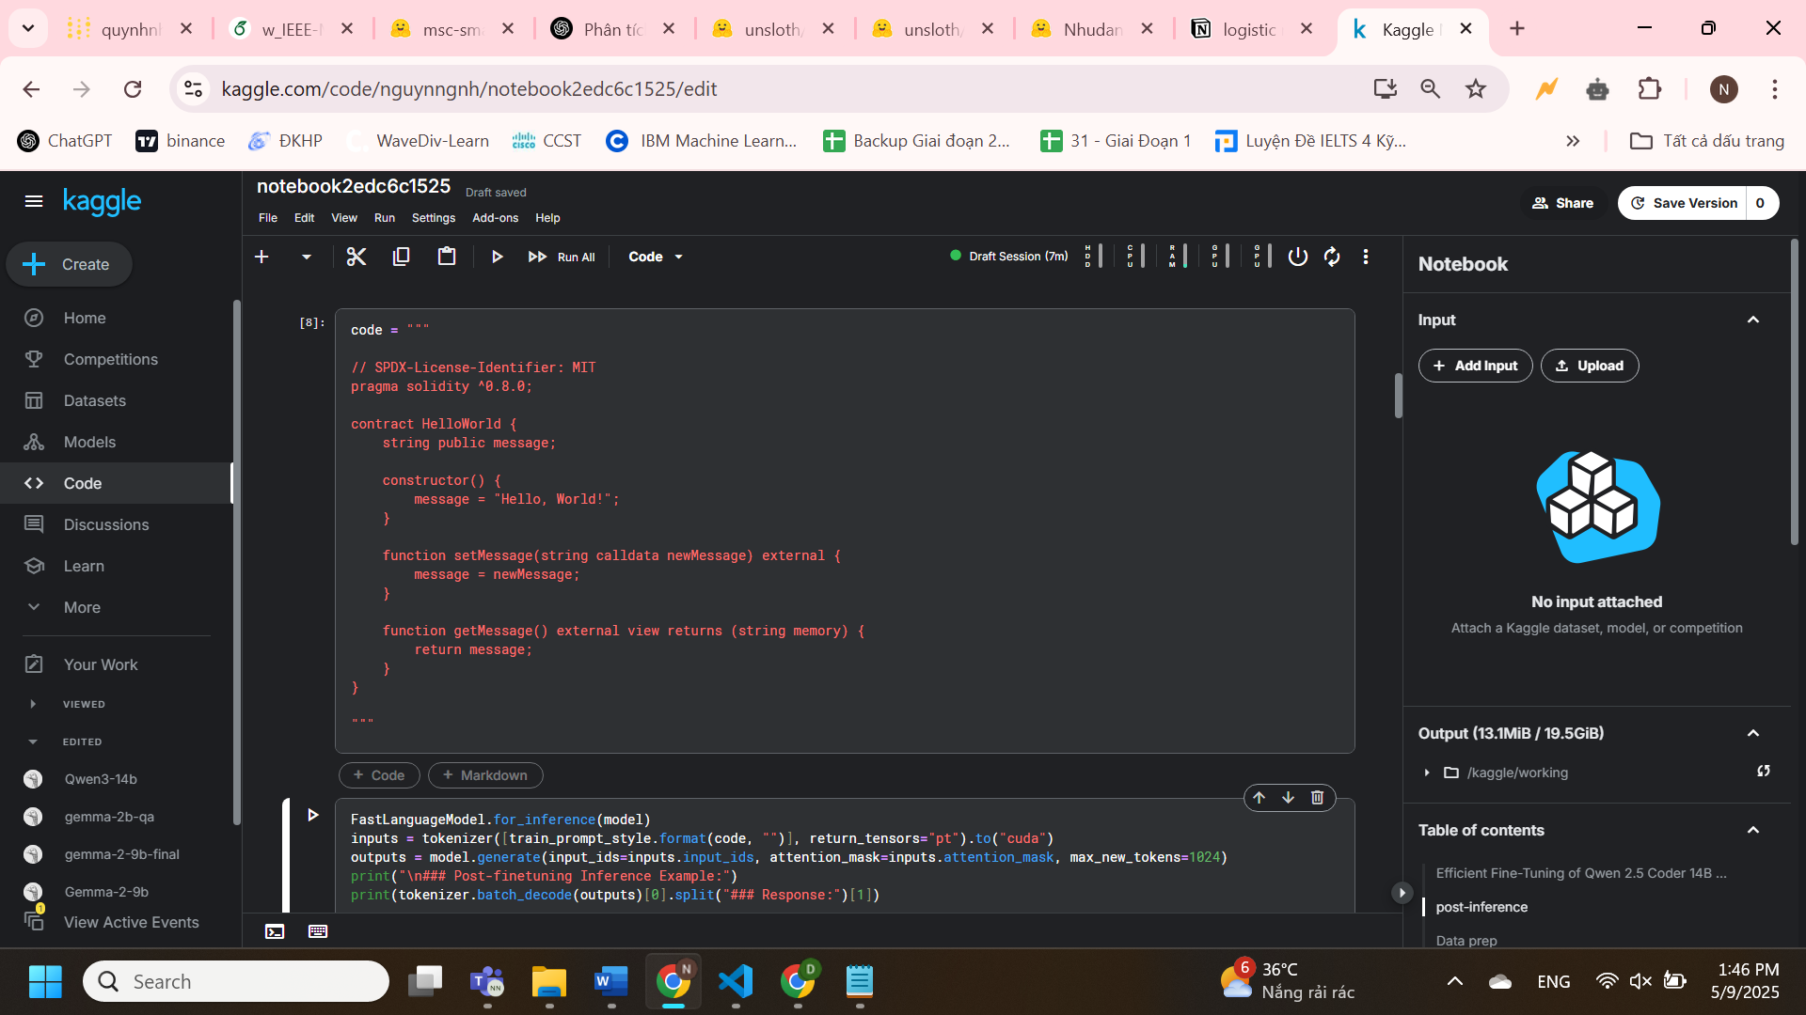
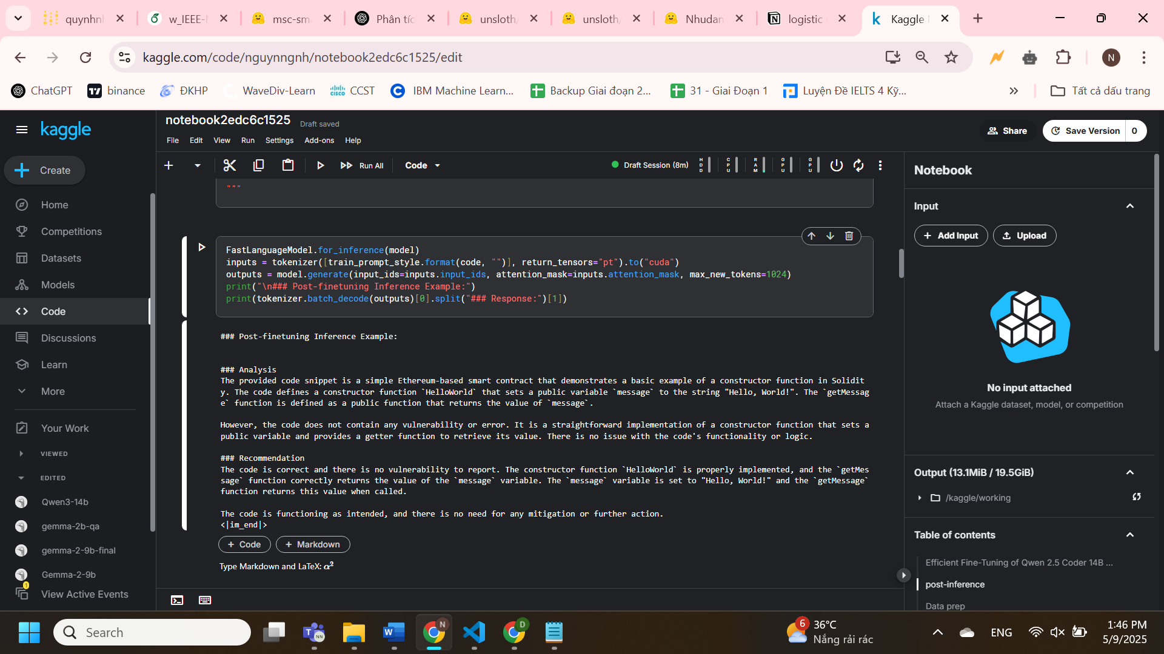
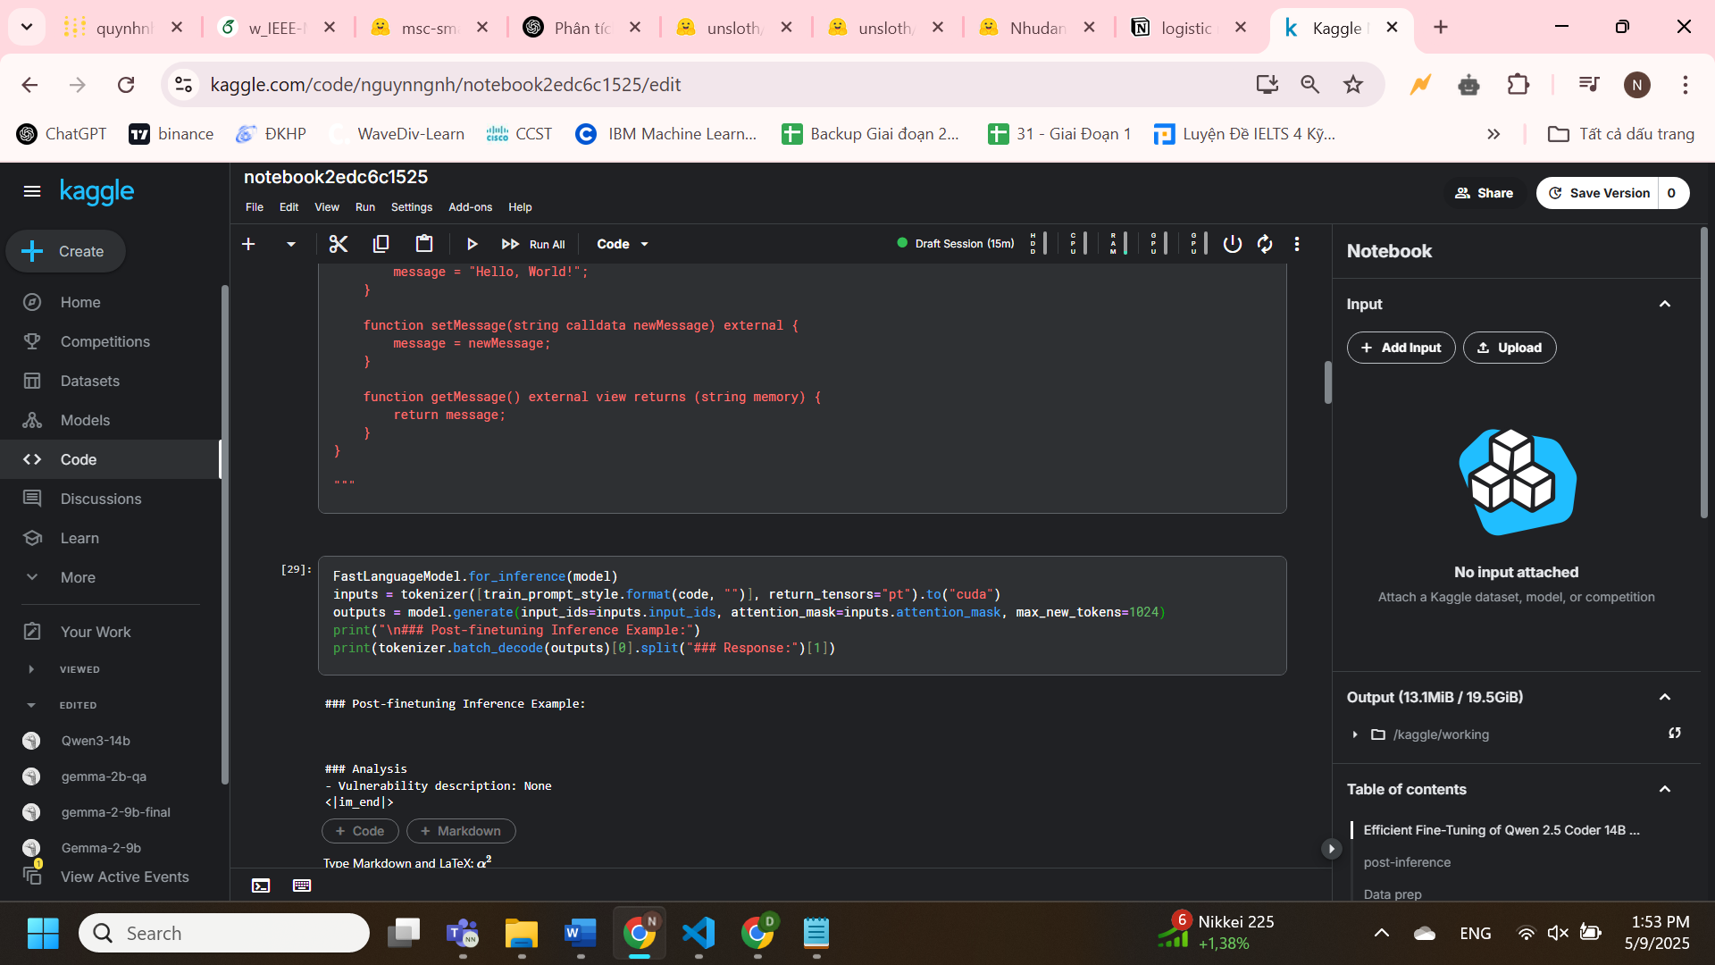

train_prompt_style = """
Below is an instruction describing a task, followed by a smart contract code snippet.

### Instruction:
You are a smart contract security assistant with deep expertise in Ethereum, Solidity, and DeFi security. Analyze the provided code snippet for any vulnerabilities
If it has vulnerabilitties, print Yes, else print No

### Code:
{}

### Response:
<think>
{}
"""
Neesu ddeer chu think thi no reference tot hon
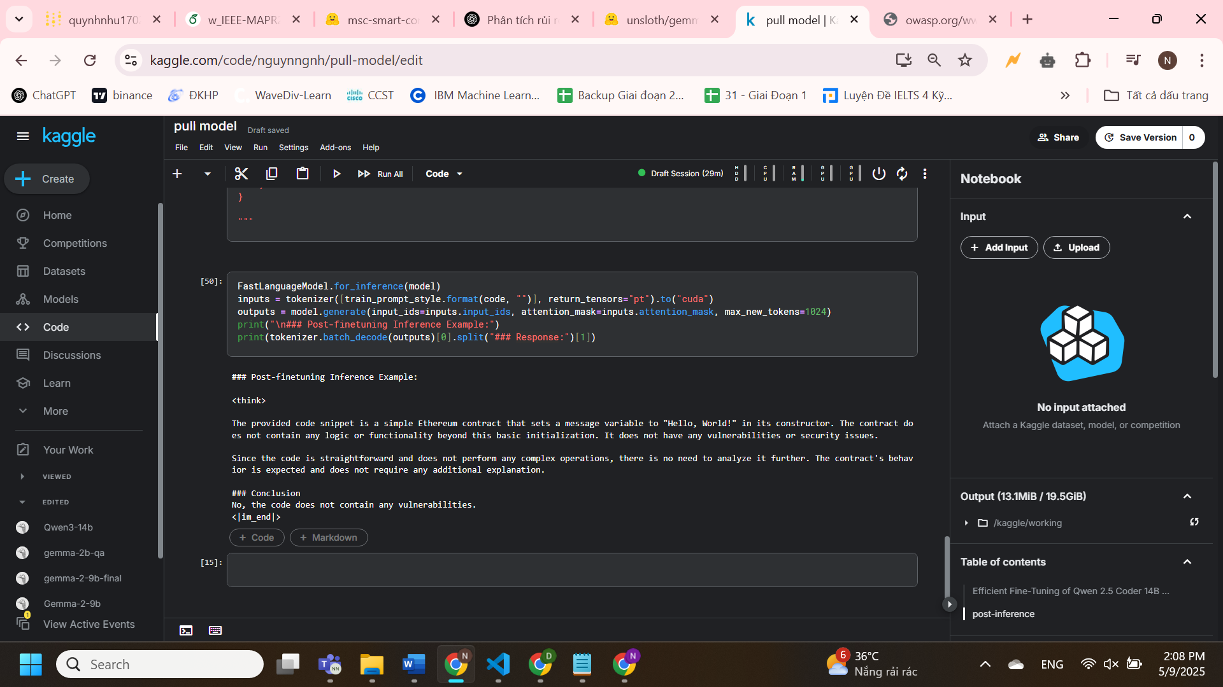

Answer with only yes or no

train_prompt_style = """
Below is an instruction describing a task, followed by a smart contract code snippet.

### Instruction:
You are a smart contract security assistant with deep expertise in Ethereum, Solidity, and DeFi security.
If it has vulnerabilitties, print Yes, else print No

### Code:
{}

### Response:
{}
"""
